XX June 2022

Dear Colleagues,
Update on Policy Integration
From when the acquisition occurred on 5 November 2021, we have been communicating with all employees who joined Calvary through the acquisition of Japara about integration matters, including the reshaping of our policies across the new organisation.
During May we wrote to you to advise that we are working on policies as a matter of priority. We advised that from 1 July 2022 Calvary HR policies will apply, and encouraged you to familiarise yourself with Calvary policies and procedures and advised that you can access on your personal device, existing and the additional devices being installed in our homes.
We highlighted the following to assist with your review of the HR policies and procedures that will apply:
- Calvary Family and Domestic Violence Leave Policy provides for 10 days paid leave (an increase of 5 days)
- Leave Policy no longer required, as the various leave policies of Calvary are tailored to the leave type, each of which align with legislative requirements.
We understand this is exciting news, and you may be interested to read and review the HR policies that apply from 1 July 2022. We encourage all employees who joined through the acquisition to read and review the HR policies. We have included in this message how to guides to provide instruction on accessing Calvary HR policies via Calvary’s intranet ‘Calvary Connect’. We confirm in addition to Calvary Connect that key HR Policies continue to be available on the integration microsite www.calvarycare.org.au/news/japara-integration.
If you have any questions, we encourage you to speak with your Manager as your first point of contact, or alternatively speak with your local HR representative.

Please note: WHS are currently undertaking a similar process in order to integrate WHS policies and procedures. More information regarding changes to WHS policies and procedures will follow over the coming months.

How to access HR Policies via Calvary Connect
- On your work desktop, click on your internet browser (either internet explorer or google chrome) – this will default to Calvary Connect as your homepage

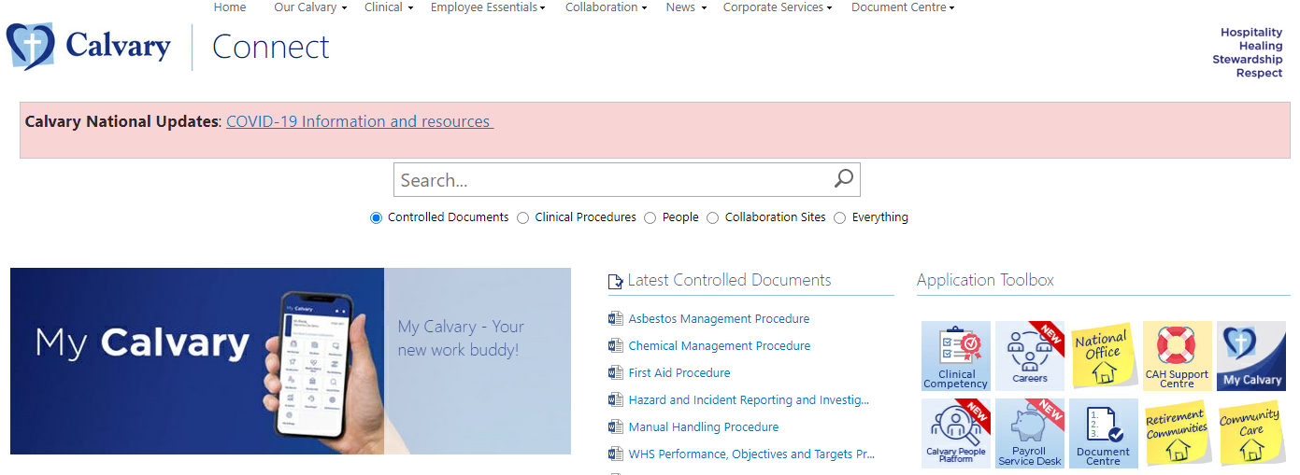
- An easy option is to type key terms into the search bar shown below OR you can hover your mouse over ‘Document Centre’ and click on ‘Policies and Procedures’
- Type the name of the HR Policy in the search bar OR select by topic/function on the left hand side
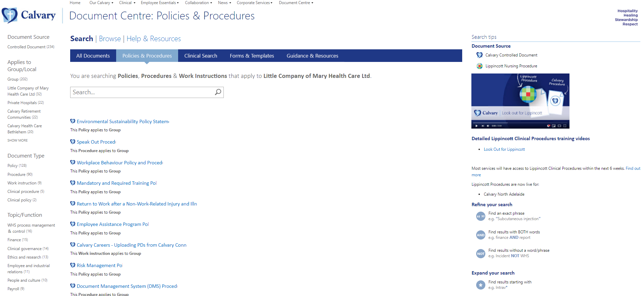

- Once the HR Policy has been located via step 4, click on the HR Policy at it will appear in the window. In the example of Criminal and Related History Screening Policy, the following will appear
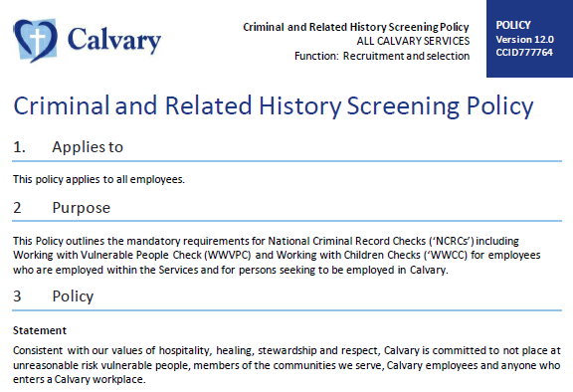

How to access HR Policies via the integration microsite
- Click the link www.calvarycare.org.au/news/japara-integration and the homepage will appear:

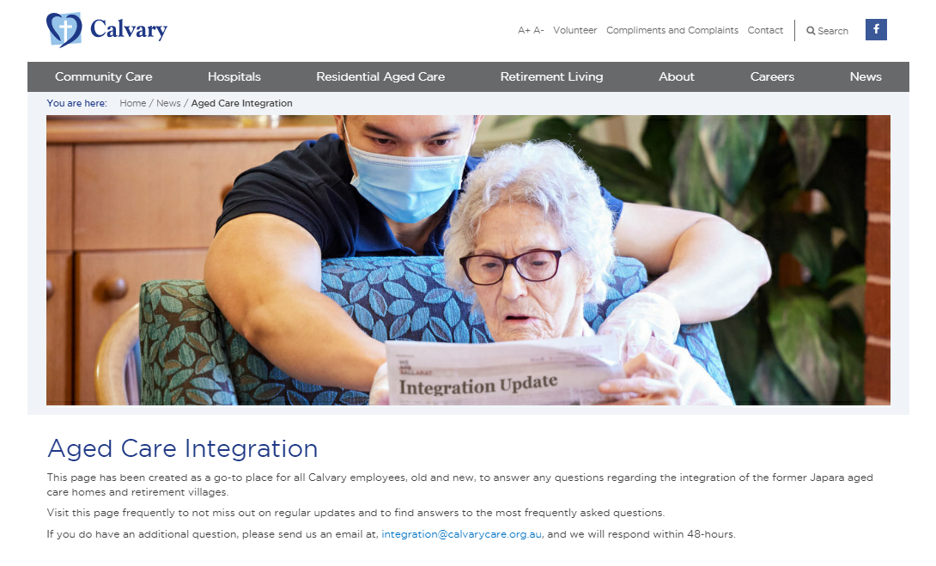

- Scroll down to the ‘Policies and Procedures’ section:
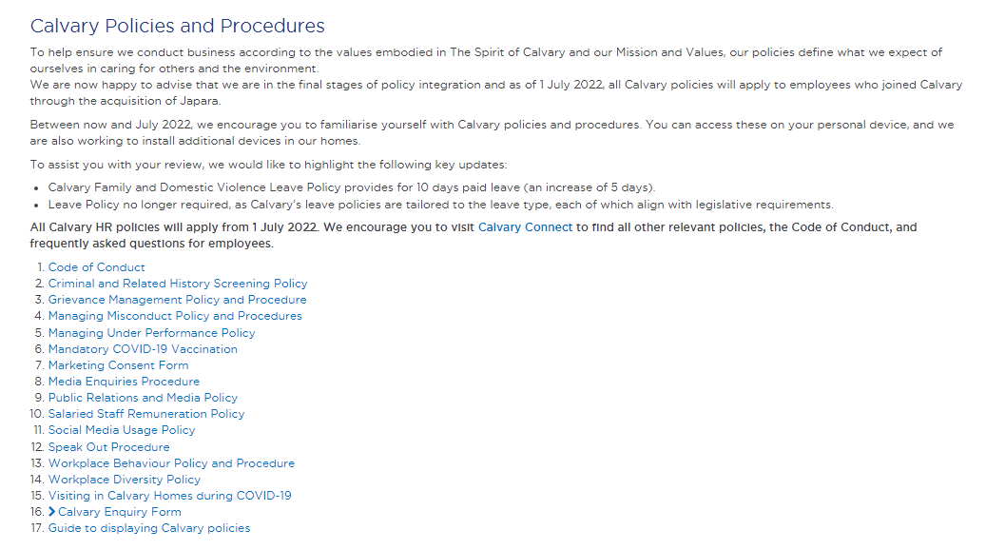
- Locate and click the policy you wish to view. For example the Criminal and Related History Screening Policy:

- In the example of Criminal and Related History Screening Policy, once clicking the document as per step 3, the following will appear

