Guide to Displaying Calvary Policies
21/03/2022
As you are aware, as part of the transition to Calvary Health Care, the policies for our aged care homes will be changed to reflect those of the Calvary organisation. We intend to improve the consistency for the display of the Policies throughout all of our homes and therefore request that you follow the guide below:
- You will receive 6 documents and frames.
  - Calvary Mission, Vision and Values
  - Spirit of Calvary
  - Safeguarding Commitment
  - Work Health Safety & Injury Management
  - Quality Care & Clinical Safety
  - Charter of Aged Care Rights (Commonwealth version)

- Please install the Policies/ Statements in the frames provided in a nominated location in the front reception area. This can be in the existing location (of the current policies) or a new location if you believe it is better suited however, it MUST be in the front reception area.
Please see below an example of the display that we have in one of our homes:
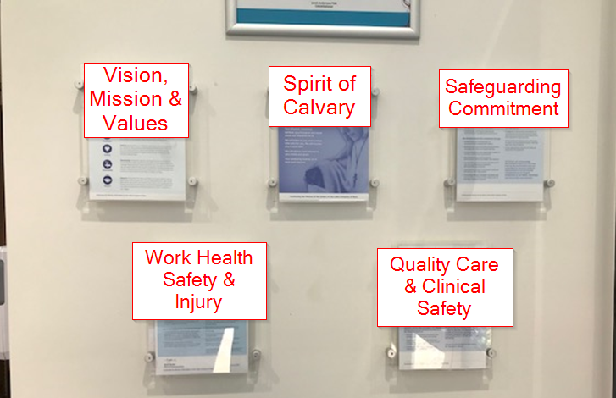

- Additionally, this is a great opportunity for the review of all documentation displayed throughout your home. We are aiming for neat presentation of our homes and request that you consider the placement and appropriateness off all documentation and remove anything that is not necessary. Please ensure that all outdated Japara and/ or ACSAG policies, information, posters etc are removed.

- Additionally, the following documents MUST also be displayed at front reception for compliance purposes:
- Accreditation Certificate – all homes
- Original Certificate of Occupancy & the most current extension(s) – Please display a maximum up to two certificates. If you do not have one or are unaware of one, please contact your regional Maintenance officer or Mick McHugh (Michael.McHugh@japara.com.au) to verify.
- Annual Fire certificates which are
  - AESMR – VIC
  - Form 3 – SA
  - AFSS – NSW
  - Occupiers Statement - QLD
  - Form 56 – TAS

- Other Policies that MUST be displayed, but do not need to be at the front reception area:
- Fire Evacuation Plan
Please ensure that any future framing of documentation is of the same type as those provided for the enclosed Policies as this is a Calvary standard.
Thank you in advance for your co-operation.

