

Name of person contactable up to an on the day)

12 November 2018

02 1234 5678 | 0439 123 456 (contactable on the day)

[sue.corlette@calvarycare.org.au](mailto:sue.corlette@calvarycare.org.au)

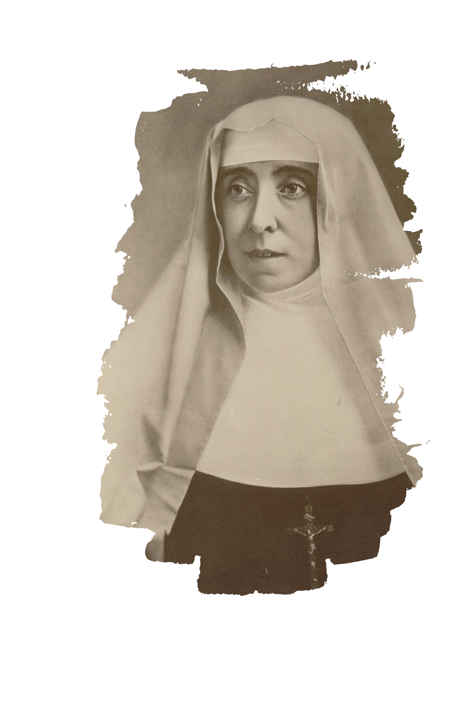

RSVP

Date: Contact:

Continuing the Mission of the Sisters of the Little Company of Mary

Invitation

Dear (name)

Join us for a reflection on the life and legacy of Venerable Mary Potter.

Date: Tuesday 24 November 2018

Time: 10am to 2pm (INCLUDE START AND FINISH TIME)

Address: Calvary Clare Holland House

include level or room if applicable Street number and name

Suburb

State or territory and postcode